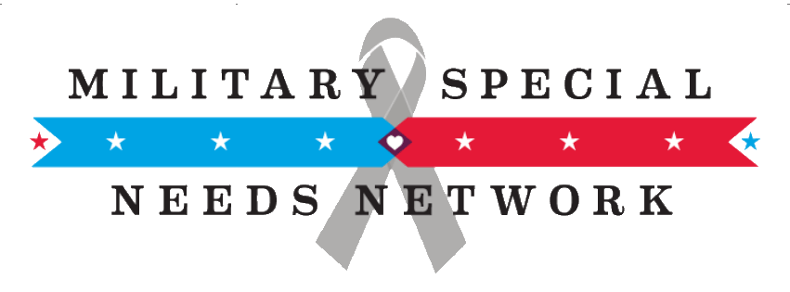
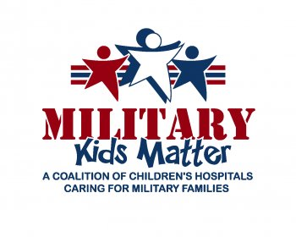
September 18, 2017

The Honorable John McCain
Chairman, Committee on Armed Services
United States Senate
Washington, DC 20515
Re: Concerns regarding impact of Medicaid cuts to military and veteran families

Dear Chairman McCain:

The Tricare for Kids (TFK) Coalition, a stakeholder group of military and veterans’ service organizations, military families, children’s healthcare advocacy and professional organizations, and disability advocacy groups, would like to express deep concerns regarding the impact of Medicaid program changes contained in the legislative proposal introduced by Senators Lindsay Graham (R-S.C.), Bill Cassidy (R-La.), Dean Heller (R-Nev.) and Ron Johnson (R-Wis.) on military and veteran families.

The Coalition has previously communicated our concerns regarding earlier versions of this bill such as the American Health Care Act (AHCA) and the Better Care Reconciliation Act (BCRA) that was eventually rejected by the Senate. The current Graham- Cassidy-Heller-Johnson proposal retains many troublesome provisions of the BCRA and fails to address or allay the concerns below.

While all children have distinct needs as compared to adults, children in military families face unique experiences due to the very nature of their parents’ service to our nation. The practical difficulties that accompany deployments and frequent relocations must be taken into consideration when fashioning the health, medical and social support systems necessary to maintain military readiness.

The Tricare for Kids Coalition is extremely concerned about the impact that a per capita funding model for Medicaid will have on military and veteran families who access Medicaid for a variety of reasons, including:

- Transitions: While recent veterans are eligible for VA health care, those without employer-sponsored coverage may rely on Medicaid for their families who no longer have Tricare and are not covered by the VA.

- Complex Conditions: For approximately 200,000 military children, Medicaid is required as a stable source of coverage for some of the most comprehensive and complex care that commercial and Tricare plans do not offer. Although the current proposal would exempt “disabled” children from per capita caps, this exemption does not protect their care options or ensure funding necessary to meet their needs.

- Secondary Insurer: Medicaid is also required to serve as a second payer to cover benefits that Tricare, tied directly to Medicare and fashioned for adults age 65 and above, does not comprehensively provide.

- Waiver Services: Medicaid waivers provide crucial services, not covered by Tricare, for those with special needs who may or may not be classified as disabled. Because the demand for these services far outstrips the supply, most states have lengthy waitlists to receive assistance. These services are often out of reach for mobile military families who have to start over at the bottom of the waitlist each time they move to a new state. Proposed cuts to the Medicaid program will result in longer waitlists for all eligible children, but with a disproportionate effect on military families.

- Pediatric infrastructure: Many military kids rely on care from the same civilian providers that take care of the more than 35 million children enrolled in Medicaid or CHIP. If that civilian infrastructure is compromised due to the proposed cuts, it will exacerbate the health care access challenges our military children already face as a result of their mobile lives.

We urge you to reject Graham-Cassidy-Heller-Johnson and Medicaid cuts of more than $40 billion in pediatric care that would limit states’ and providers’ ability to provide services to all children, including children of military and veteran families. Thank you for your consideration. We stand ready to discuss or provide further information at your convenience.

Tricare for Kids Coalition
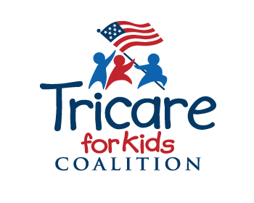
cc: Senate and House Armed Services Committees

