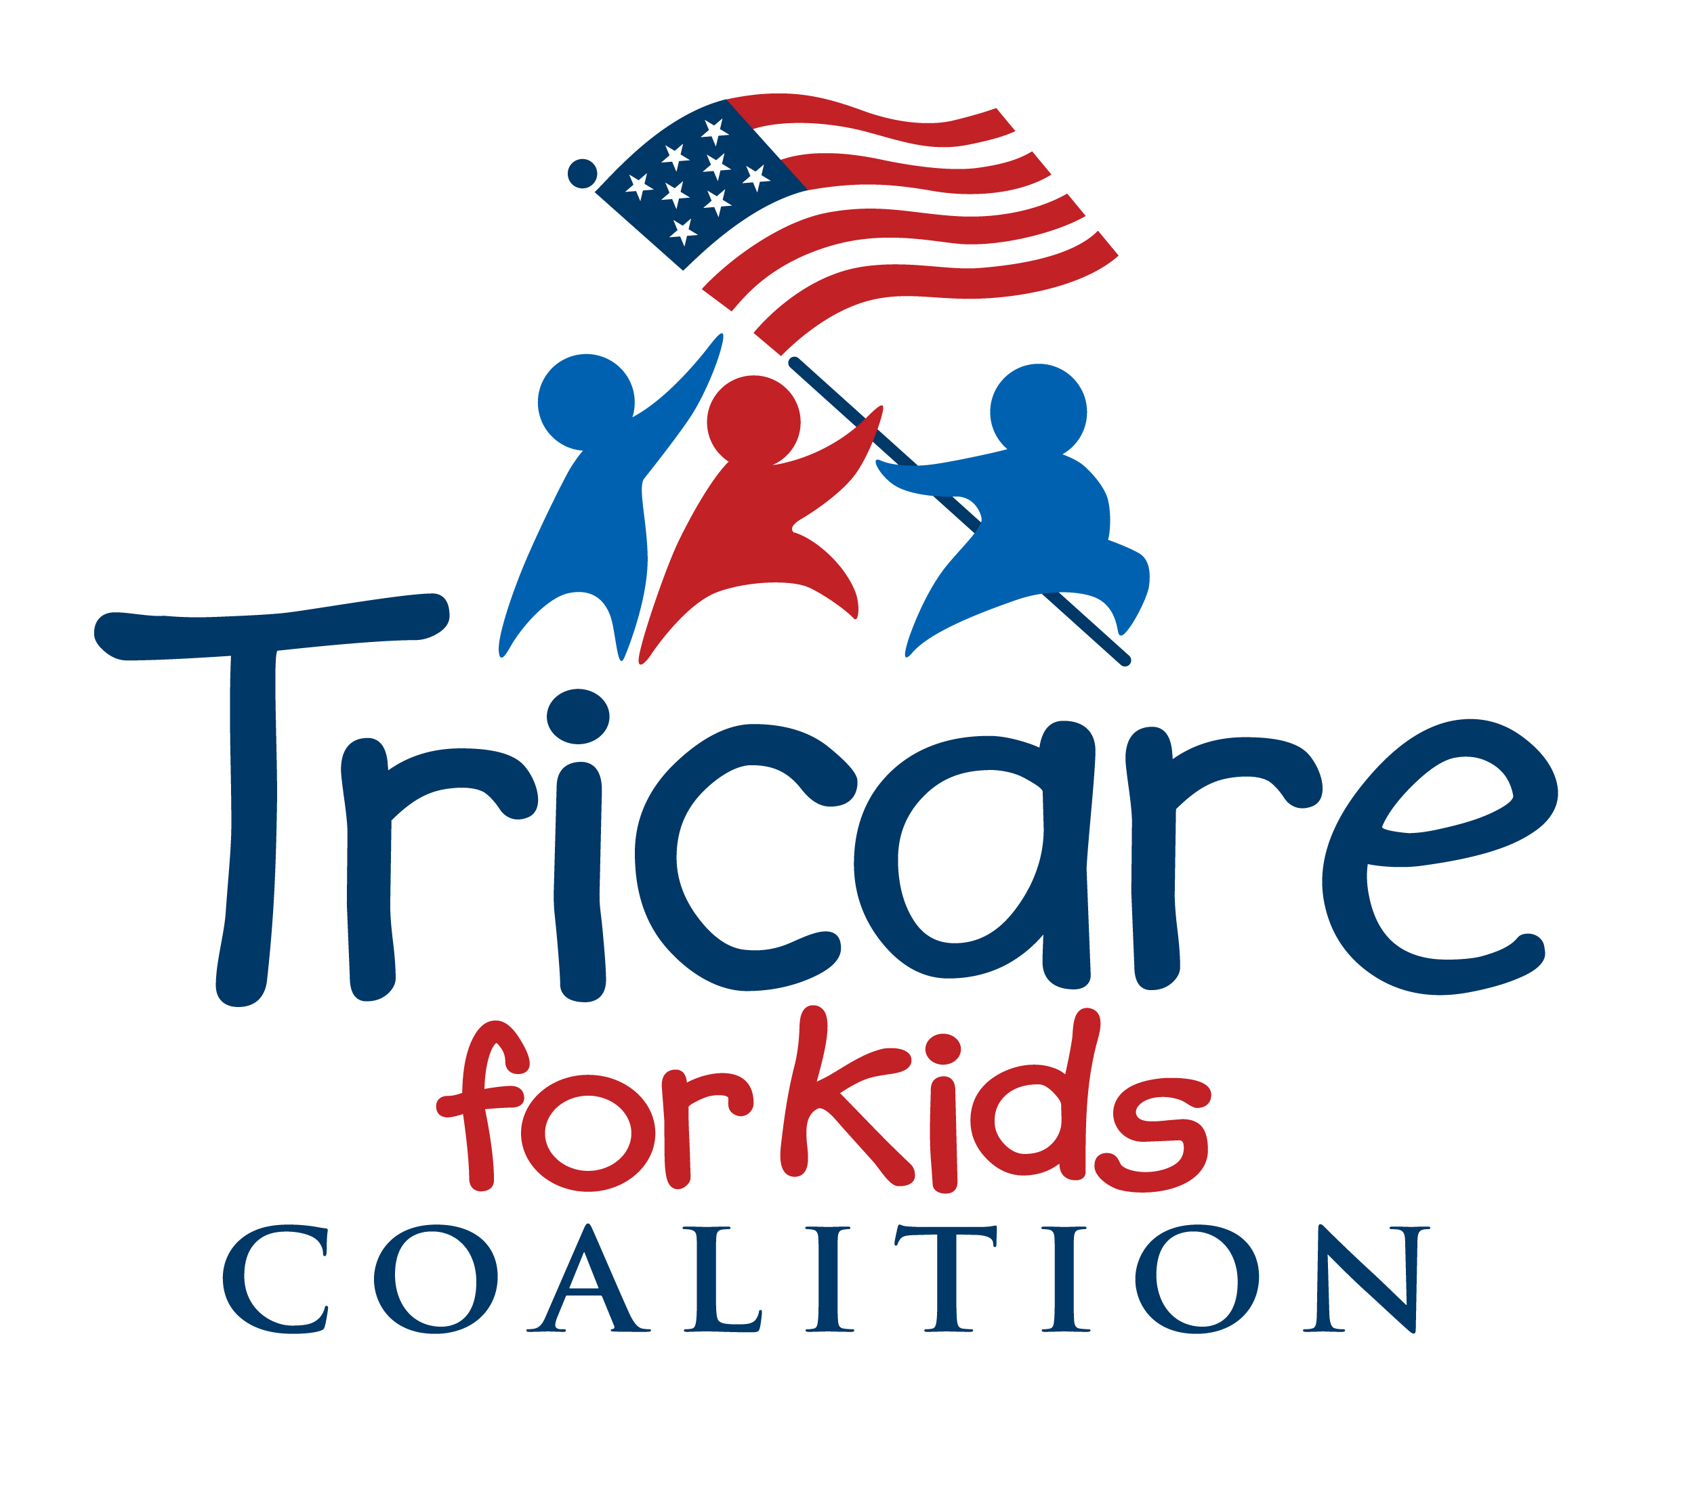

The Tricare for Kids (TFK) Coalition is a stakeholder group of children’s healthcare advocacy and professional organizations, disability advocacy groups, military and veterans’ service organizations, and military families committed to ensuring that TRICARE meets the unique health needs of the more than two million children of military families covered by TRICARE.

While all children have unique needs as compared to adults, children in military families face unique experiences due to the very nature of their parents’ service to our nation. The practical difficulties that accompany deployments and frequent relocations must be taken into consideration when fashioning the health, medical and social support systems necessary to serve these families. These considerations take on an even higher significance when a military family is caring for a child with complex or chronic medical conditions.

Thank you for the opportunity to submit comments and supporting material for the December 14 meeting. While Coalition partners have invaluable and unique perspectives and expertise, not all members were able to submit individually because of the short notice and difficult timing. Therefore, the Tricare for Kids Coalition is submitting aggregate comments, and urges follow up discussion with individual members on December 14 or beyond where it would prove helpful.

The comprehensive documents provided herein are pertinent to the broader charge by the Defense Health Agency to the Defense Health Board, and to that end, we submit the attached resources for context and background.

For December 14 meeting purposes, we address the two meeting topics related to the disadvantages to military children of a system based on Medicare, and the need for a pediatric specific medical necessity definition and reinforcing policies, noting that these issues are interrelated with the topics of receiving age and developmentally appropriate services and access to those services.
Tricare for Kids Coalition
Comments to the Defense Health Board Subcommittee on Healthcare Delivery
December 14 meeting re pediatric health care services

- One of the foundational problems with the current TRICARE program is its reliance on Medicare, an adult-based health care plan and payment system.

Children’s health care needs and standards of care are different and distinct from those of adults. Because they continually grow and develop, early identification and intervention for all care needs, and robust specialty care and services for children with special health care needs and chronic health conditions are especially critical.

Children utilize care at different rates, in different settings, and for different conditions than do adults. Additionally, reimbursement based on Medicare often leaves the family or provider subsidizing the cost of pediatric care. This occurs when policies such as Medicare’s inpatient only list result in denial of care even when provided consistent with the pediatric standard of care; when services that children need but adults do not, are ostensibly “covered” but not included in the relative value of the payment code (examples of this include Melody Heart Valves, conscious sedation for an MRI or wound care);; and when adherence to Medicare policy results in parents being forced to deny curative care to their children in order to access hospice services.

Recommendation: DoD should comprehensively address the specific needs of children, using the following framework of principles and facts that distinguish the different care needs of children versus adults.

- Children are dependent on their parents and families.
- Pediatric Care is regional in nature
- Children with special health needs and complex medical conditions require an array of primary, acute, post-acute, highly specialized, therapeutic, and continuing care, treatment, services and supports.
- Pediatric volumes are less than adult volumes.
- Children’s health is influenced by many entities outside of the health care arena.
- Children require services and care in a timely manner specifically suited to their unique development and growth needs.
- Measures and methods are different when judging quality and outcomes for children as compared to adults.
- Hospitalization rates and reasons are very different than for adults.
- Children have specialized pharmaceutical needs.

- A general or adult based medical necessity definition and the resultant hierarchy of evidence requirement leaves children’s needs unmet with fragmented (under the ancillary program, ECHO) or non coverage of medically necessary care such as ventilator support, habilitation, medical nutrition therapy, compound medication and other specialty pharmaceuticals.

DHA hierarchy of reliable evidence includes only “published research based on well controlled clinical studies, formal technology assessments, and/or published national medical organization policies/positions/Reports.” Evidence of effectiveness is a cornerstone of medical necessity, yet such tightly prescribed data for children is not always readily available. Due to their very nature of constant growth and development, and a societal responsibility to protect children, they are not always the subject of such controlled and prescribed studies. Strict adherence to this adult based hierarchy of evidence will result in children not receiving the care and treatment they need; that is widely and more quickly accepted and practiced elsewhere in the healthcare system.

Children with complex needs often receive some medically necessary care pursuant to ECHO while their families are eligible. Skilled nursing and ventilator support, for example for a child with spinal muscular atrophy is medically necessary yet not covered by Tricare basic.

Similarly, habilitative services, provided in order for a person to attain a skill or function never learned, or maintain, or prevent deterioration of skill or function, are uniquely necessary for children, due to their stages of growth and development. Habilitative services should be covered as a basic program health benefit.

TRICARE does not regularly cover medical nutritional therapy, forcing pediatric providers and families to make care decisions that may be less than optimal. It is especially critical that it be offered as covered, medically necessary care and treatment for children due to their unique growth and development needs, and is critical as an element of care in multi-disciplinary specialty clinics caring for children with complex needs.

Compounded medications are often the only safe and effective medications for children with chronic disabilities, for those with allergies to commercial additives, or infants and children who cannot tolerate an adult dose, for lifesaving medications that must be specially formulated, and in cases of drug shortages in which medication is not otherwise available. Medications commercially manufactured for adults are often packaged in doses too large or too strong, and often must be converted from solid to liquid for infants

Recommendation: DoD should adopt the pediatric definition of medical necessity, and commensurate hierarch of evidence standards as recommended by the AAP.
Pediatrics Official Journal of the American Academy of Pediatrics. Committee of Child Health Financing Pediatrics 2013 http://pediatrics.aappublications.org/content/132/2/398.full.html

